**pom.xml:**

*<?*xml version="1.0" encoding="UTF-8"*?>*<project xmlns="http://maven.apache.org/POM/4.0.0"  
 xmlns:xsi="http://www.w3.org/2001/XMLSchema-instance"  
 xsi:schemaLocation="http://maven.apache.org/POM/4.0.0 http://maven.apache.org/xsd/maven-4.0.0.xsd">  
 <modelVersion>4.0.0</modelVersion>  
  
 <groupId>org.example</groupId>  
 <artifactId>LibraryManagement</artifactId>  
 <version>1.0-SNAPSHOT</version>  
  
 <properties>  
 <maven.compiler.source>20</maven.compiler.source>  
 <maven.compiler.target>20</maven.compiler.target>  
 <project.build.sourceEncoding>UTF-8</project.build.sourceEncoding>  
 </properties>  
 <dependencies>  
 *<!-- Spring Core Context -->* <dependency>  
 <groupId>org.springframework</groupId>  
 <artifactId>spring-context</artifactId>  
 <version>5.3.32</version>  
 </dependency>  
 </dependencies>  
</project>

**applicationContext.xml:**

*<?*xml version="1.0" encoding="UTF-8"*?>*<beans xmlns="http://www.springframework.org/schema/beans"  
 xmlns:xsi="http://www.w3.org/2001/XMLSchema-instance"  
 xsi:schemaLocation="  
 http://www.springframework.org/schema/beans  
 http://www.springframework.org/schema/beans/spring-beans.xsd">  
  
 *<!-- Define BookRepository Bean -->* <bean id="bookRepository" class="com.library.repository.BookRepository" />  
  
 *<!-- Define BookService Bean and inject BookRepository -->* <bean id="bookService" class="com.library.service.BookService">  
 <property name="bookRepository" ref="bookRepository" />  
 </bean>  
  
</beans>

**Exercise 1: Configuring a Basic Spring Application**

**CODE:**

**BookRepository.java:**

package com.library.repository;  
public class BookRepository {  
 public void saveBook(String title) {  
 System.*out*.println("Book '" + title + "' saved to the repository.");  
 }  
 }

**BookService.java:**

package com.library.service;  
import com.library.repository.BookRepository;  
public class BookService {  
 private BookRepository bookRepository;  
 *// Setter for Spring to inject the dependency* public void setBookRepository(BookRepository bookRepository) {  
 this.bookRepository = bookRepository;  
 }  
 public void addBook(String title) {  
 bookRepository.saveBook(title);  
 System.*out*.println("BookService: Book '" + title + "' added successfully.");  
 }  
}

**MainApp.java:**

package com.library;  
import com.library.service.BookService;  
import org.springframework.context.ApplicationContext;  
import org.springframework.context.support.ClassPathXmlApplicationContext;  
public class MainApp {  
 public static void main(String[] args) {  
 ApplicationContext context = new ClassPathXmlApplicationContext("applicationContext.xml");  
 BookService bookService = (BookService) context.getBean("bookService");  
 bookService.addBook("Spring in Action");  
 }  
}

**OUTPUT:**

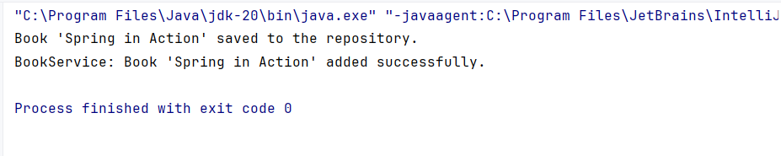

**Exercise 2: Implementing Dependency Injection**

**CODE:**

**BookRepository.java:**

package com.library.repository;  
import java.util.Arrays;  
import java.util.List;  
public class BookRepository {  
 public List<String> findAllBooks() {  
 return Arrays.*asList*("The Alchemist", "Clean Code", "Java: The Complete Reference");  
 }  
}

**BookService.java:**

package com.library.service;  
import com.library.repository.BookRepository;  
import java.util.List;  
public class BookService {  
 private BookRepository bookRepository;public void setBookRepository(BookRepository bookRepository) {  
 this.bookRepository = bookRepository;  
 }  
 public void displayBooks() {  
 List<String> books = bookRepository.findAllBooks();  
 System.*out*.println("Books available in the library:");  
 for (String book : books) {  
 System.*out*.println("- " + book);  
 }  
 }  
}

**MainApp.java:**

package com.library;  
import com.library.service.BookService;  
import org.springframework.context.ApplicationContext;  
import org.springframework.context.support.ClassPathXmlApplicationContext;  
public class MainApp {  
 public static void main(String[] args) {  
 ApplicationContext context = new ClassPathXmlApplicationContext("applicationContext.xml");  
 BookService bookService = (BookService) context.getBean("bookService");  
 bookService.displayBooks();  
 }  
}

**OUTPUT:**

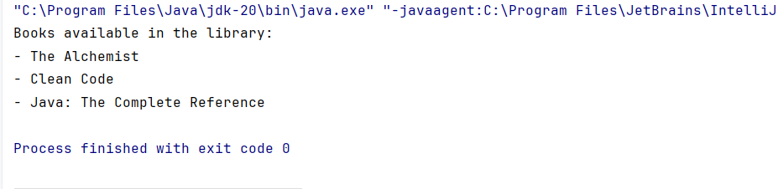

**Exercise 4: Creating and Configuring a Maven Project**

**CODE:**

**pom.xml:**

<project xmlns="http://maven.apache.org/POM/4.0.0"  
 xmlns:xsi="http://www.w3.org/2001/XMLSchema-instance"  
 xsi:schemaLocation="http://maven.apache.org/POM/4.0.0  
 http://maven.apache.org/xsd/maven-4.0.0.xsd">  
 <modelVersion>4.0.0</modelVersion>  
 <groupId>com.library</groupId>  
 <artifactId>LibraryManagement</artifactId>  
 <version>1.0-SNAPSHOT</version>  
 <dependencies>  
 *<!-- Spring Core Context -->* <dependency>  
 <groupId>org.springframework</groupId>  
 <artifactId>spring-context</artifactId>  
 <version>5.3.34</version>  
 </dependency>  
 *<!-- Spring AOP -->* <dependency>  
 <groupId>org.springframework</groupId>  
 <artifactId>spring-aop</artifactId>  
 <version>5.3.34</version>  
 </dependency>  
 *<!-- Spring WebMVC -->* <dependency>  
 <groupId>org.springframework</groupId>  
 <artifactId>spring-webmvc</artifactId>  
 <version>5.3.34</version>  
 </dependency>  
 </dependencies>  
 <build>  
 <plugins>  
 *<!-- Maven Compiler Plugin -->* <plugin>  
 <groupId>org.apache.maven.plugins</groupId>  
 <artifactId>maven-compiler-plugin</artifactId>  
 <version>3.8.1</version>  
 <configuration>  
 <source>1.8</source>  
 <target>1.8</target>  
 </configuration>  
 </plugin>  
 </plugins>  
 </build>  
</project>

**AppConfig.java:**

package com.library;  
import org.springframework.context.annotation.ComponentScan;  
import org.springframework.context.annotation.Configuration;  
@Configuration  
@ComponentScan("com.library")  
public class AppConfig {  
}

**Book.java:**

package com.library;  
import org.springframework.stereotype.Component;  
@Component  
public class Book {  
 public void display() {  
 System.*out*.println("Book: Spring in Action");  
 }  
}

**LibraryApp.java:**

package com.library;  
import org.springframework.context.ApplicationContext;  
import org.springframework.context.annotation.AnnotationConfigApplicationContext;  
public class LibraryApp {  
 public static void main(String[] args) {  
 ApplicationContext context = new AnnotationConfigApplicationContext(AppConfig.class);  
 Book book = context.getBean(Book.class);  
 book.display();  
 }  
}

**OUTPUT:**

